**Assignment 2 Template**

**Problem 2 (35 marks): The first three numbers in your Exponential data set are:**

|  |  |  |
| --- | --- | --- |
| **0.09732122** | **0.14488118** | **0.16018111** |

**theta = 1.777097**

**The maximum likelihood of theta is thetahat = 1.703067**

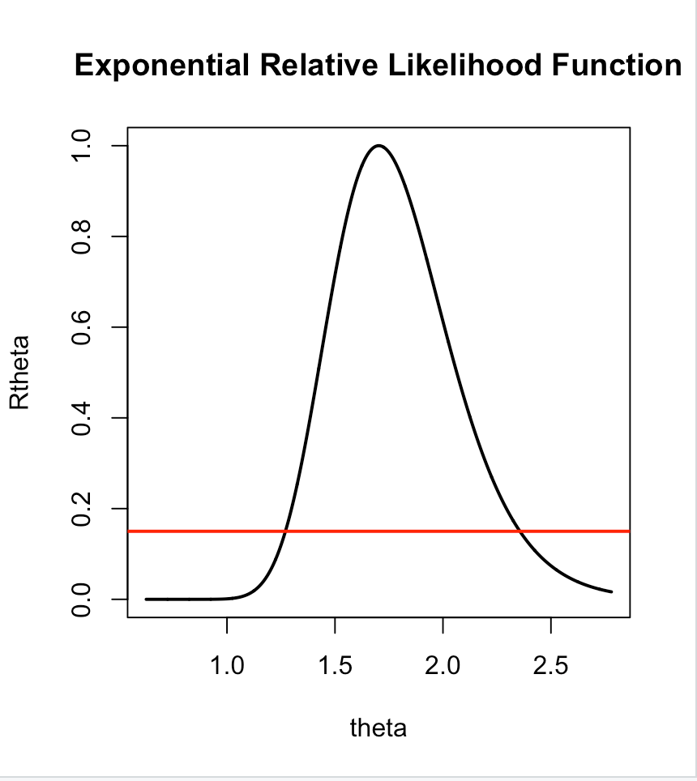**Insert the plot of the Exponential relative likelihood function here.**

**Based on the graph of the relative likelihood function and the line y = 0.15 the 15% likelihood interval for theta is: [1.25, 2.35]**

**Using the R function uniroot the 15% likelihood interval is: [1.270571, 2.356235]**

**(NOTE: To find the endpoints of the likelihood interval using**

uniroot(function(x) ExpRLF(x)-0.15,lower=2.8,upper=3)

**you will need to change** “lower=2.8,upper=3” **to values that work for your data.)**

**Is theta = 2 a plausible value of theta for your data set? Why? (Refer to Table 4.2 in the Course Notes)**

Theta = 2 is a very plausible value for the data set because this theta is inside 50% likelihood interval in light of observed data due to Table 4.2

**Is theta = 8 a plausible value of theta for your data set? Why? (Refer to Table 4.2 in the Course Notes)**

Theta = 8 is a very implausible value for the data set because this theta is outside 1% likelihood interval in light of observed data due to Table 4.2

**The maximum likelihood estimate of the median of this distribution is: 1.703067**